NAME – ANJALI GUPTA

EMAIL – [ANJALI14692@GMAIL.COM](mailto:ANJALI14692@GMAIL.COM)

ASSIGNMENT 2

ASDM

1. CREATE A PROJECT :

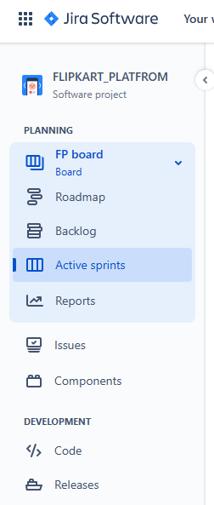

1. CREATE COMPONENTS :

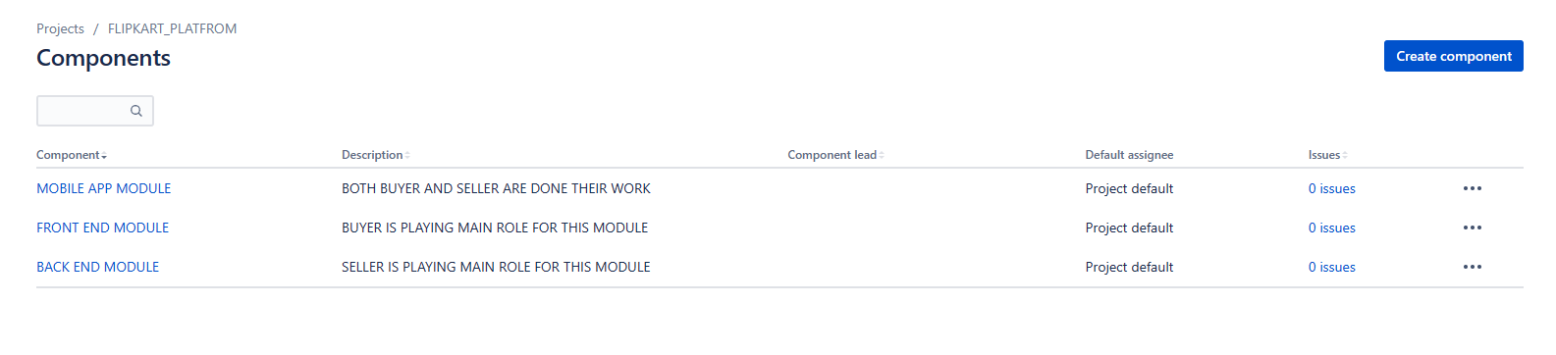

1. PLAN THE VERSION WITH RELEASE DATE :

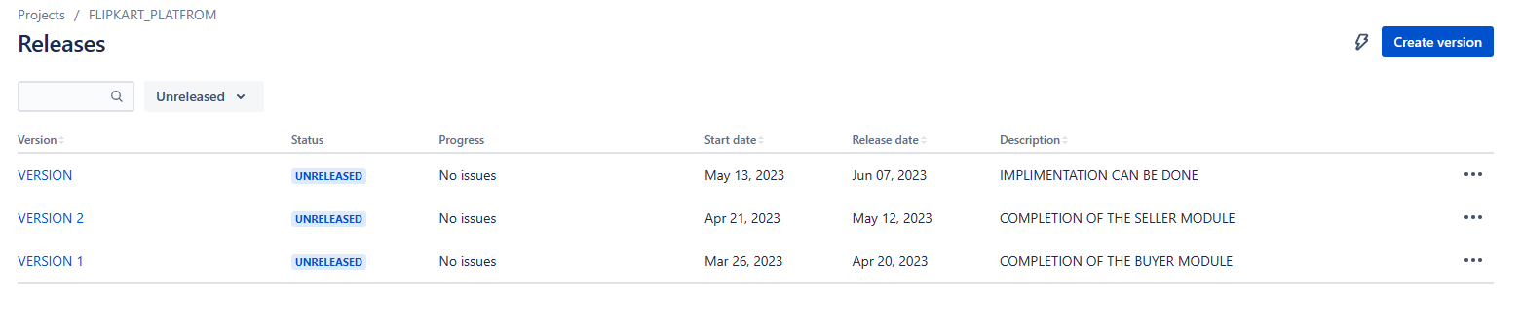

1. CREATE A SPRINTS BACKLOG, START SPRINT AND COMPLETE SPRINT :

STORY INITIALIZE STORY POINT, ASSOCIATE WITH VERSION AND COMPNENTS

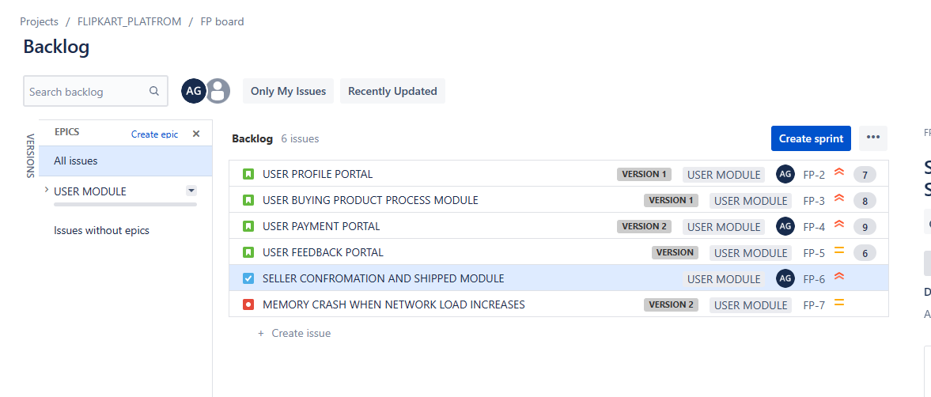

5) STORY DIVIDED INTO SUBTASK :

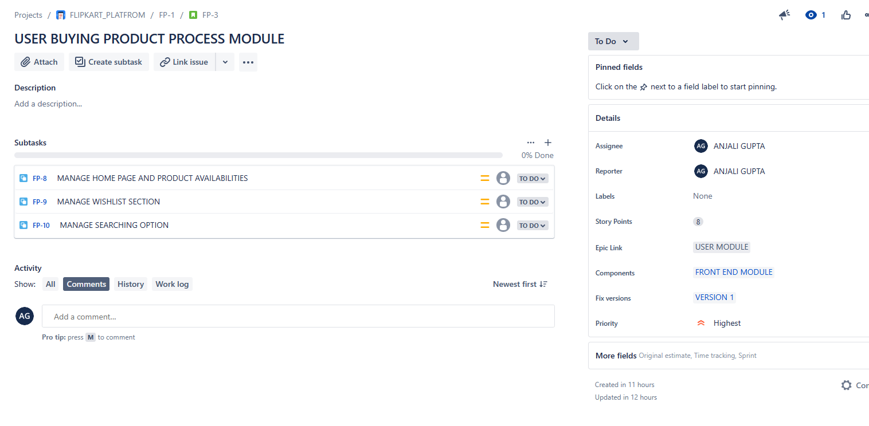

6)

CREATE DIFFERENT TYPES OF ISSUES IN THE BACKLOG EPIC – PROVIDE EPIC LINK ALSO

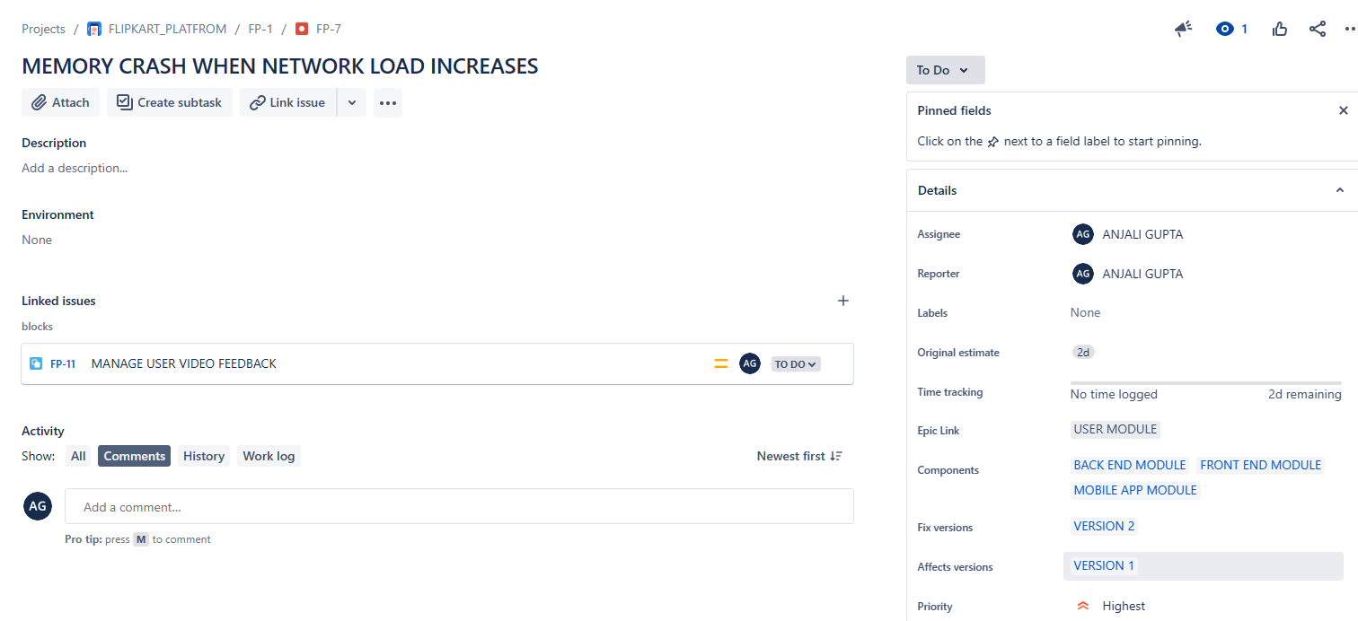



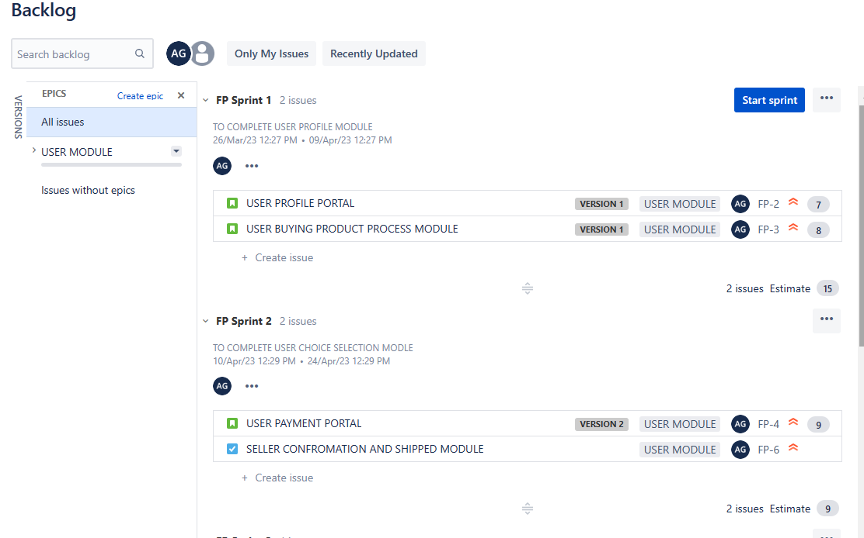

START SPRINTS :

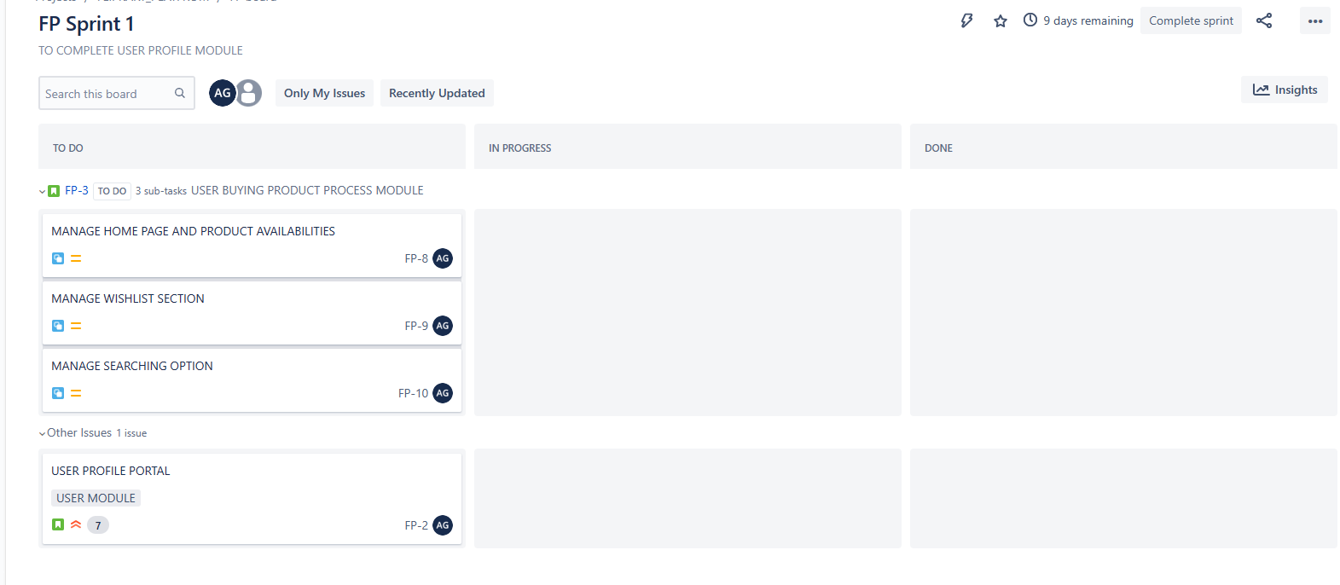

SPRINTS 2 IS IN PROGRESS :

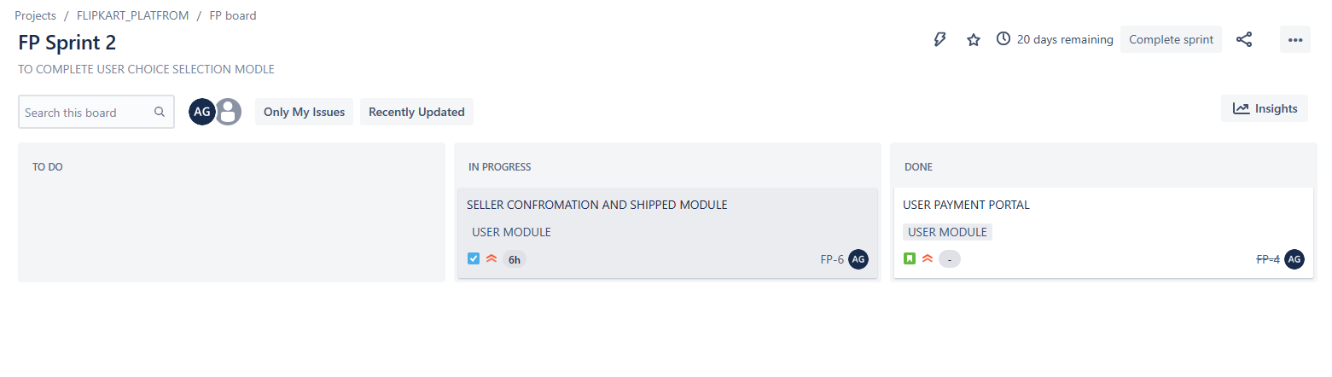

SPRINT BURNDOWN CHART :

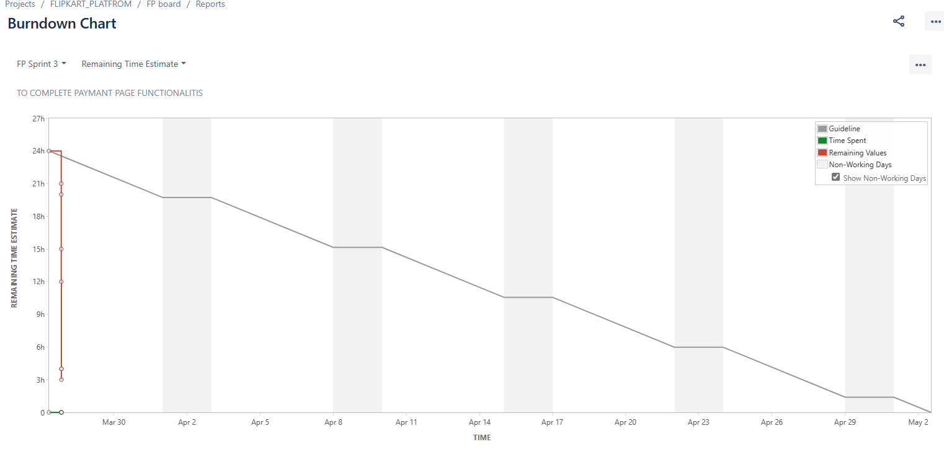

SPRINTS BURNUP CHART :

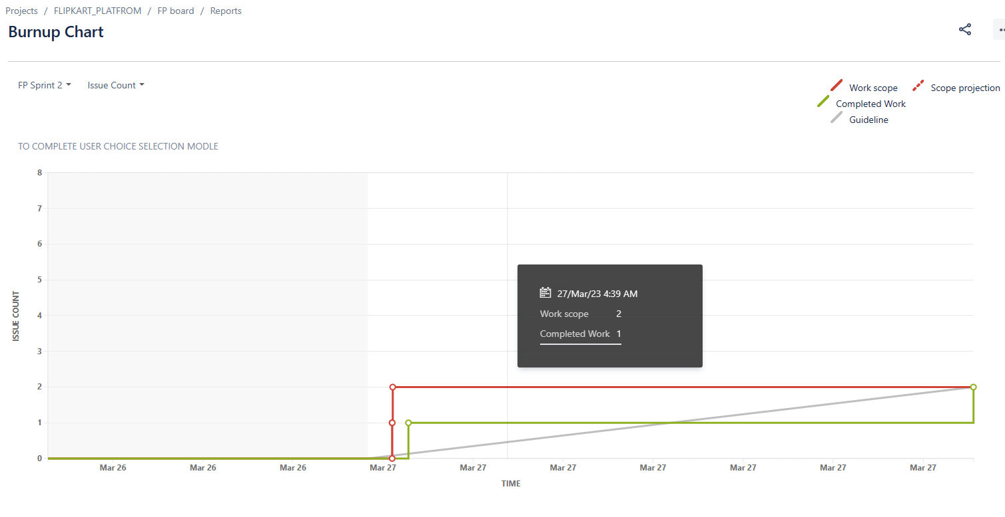

VELOCITY CHART :

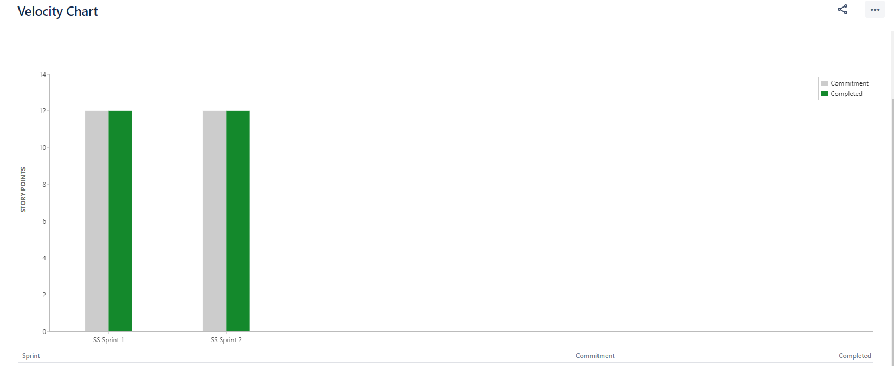

SPRINT REPORT :

